**Project Design Phase**

**Technology Stack (Architecture & Stack)**

|  |  |
| --- | --- |
| Date | 15 April 2025 |
| Team ID | SWTID1743695015 |
| Project Name | Shopez: E-Commerce Application |
| Maximum Marks | 4 Marks |

**Technical Architecture:**

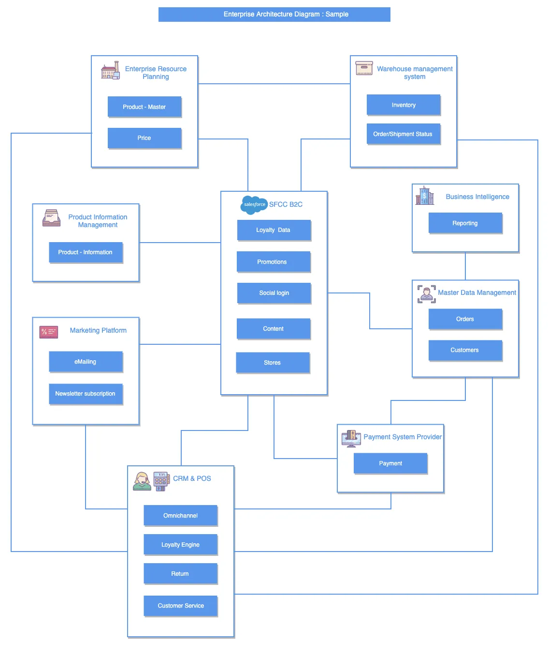

**Table-1: Components & Technologies:**

|  |  |  |  |
| --- | --- | --- | --- |
| **Sl.No** | **Component** | **Description** | **Technology** |
|  | Enterprise Resource Planning | |  | | --- | |  |  |  | | --- | | Manages core business processes like product  master data and pricing. | | SAP, Oracle ERP, Microsoft Dynamics |
|  | Warehouse Management System | |  | | --- | |  |  |  | | --- | | Handles inventory tracking and shipment/order  status updates. | | |  | | --- | |  |  |  | | --- | | Manhattan WMS, SAP EWM, Oracle  WMS | |
|  | Product Information Management | Centralizes and manages product data for accuracy across platforms. | Akeneo, Salsify, Informatica PIM |
|  | Marketing Platform | Executes marketing campaigns including emails and newsletters. | |  | | --- | |  |  |  | | --- | | Mailchimp, Salesforce Marketing  Cloud, HubSpot | |
|  | CRM & POS | |  | | --- | |  |  |  | | --- | | Customer Relationship Management and  Point of Sale for loyalty, returns, etc. | | Salesforce CRM, Oracle POS, Lightspeed, Square POS |
|  | SFCC B2C (Salesforce Commerce Cloud) | Central eCommerce platform handling promotions, content, loyalty, etc. | Salesforce B2C Commerce (formerly Demandware) |
|  | Master Data Management | Maintains consistent data across systems—orders and customer records. | Informatica MDM, IBM InfoSphere, Talend |
|  | Payment System Provider | Manages and processes customer payments securely. | Stripe, PayPal, Adyen, Razorpay |
|  | Business Intelligence | |  | | --- | |  |  |  | | --- | | Analyzes business data and provides reporting and dashboards. | | Power BI, Tableau, Looker, Qlik |

**Table-2: Application Characteristics:**

| **Sl.No** | **Characteristics** | **Description** | **Technology** |
| --- | --- | --- | --- |
|  | Centralized Business Logic | |  | | --- | |  |  |  | | --- | | Core backend system managing product  master data and pricing. | | SAP, Oracle ERP, Microsoft Dynamics |
|  | Real-time Inventory & Shipment Tracking | Tracks stock levels and order/shipment status for fulfillment. | |  | | --- | |  |  |  | | --- | | SAP EWM, Manhattan Associates,  Oracle WMS | |
|  | Centralized Product Data | Maintains consistent and updated product details across platforms. | Akeneo, Salsify, Informatica PIM |
|  | Automated Customer Outreach | Runs targeted campaigns via email and newsletters. | |  | | --- | |  |  |  | | --- | | Mailchimp, Salesforce Marketing Cloud, HubSpot | |
|  | Secure Payment Processing | Facilitates encrypted and compliant online payments. | Stripe, PayPal, Razorpay, Adyen |